**Lesson 4: Graphing Technologies**

After completing this lesson, you should be able to

* discuss various graphing technologies
* change the settings of the graphing window to get accurate results
* interpret the results you get using graphing technologies

**Commentary**

**Topics**

1. [Graphing Technologies](https://content.umuc.edu/file/7bdece95-b196-4233-9313-aa904663b08e/1/MATH140-0909.zip/Modules/M1-Module_1/Lesson_4/S3-Commentary.html#I)

**1. Graphing Technologies**

Graphing calculators and computers with graphing software are considered graphing technologies. We assume that you have access to a graphing technology. With graphing technologies, you can solve equations graphically and graph some functions more quickly than by hand.

Graphing technologies typically render a graph in a rectangular display window called a **viewing screen** or**graphing window**. As the graphing window can give a misleading or incomplete representation of a graph, we must carefully set it up by choosing the appropriate *x*- and *y*-values. The *x*-values to consider for the graphing window are *x*-min, *x*-max, and *x*-scl (the unit distance between tick marks on the *x*-axis); and *y*-min, *y*-max, and *y*-scl (the unit distance between tick marks on the *y*-axis).

When we write the **dimensions** for the graphing window—<*x*-min, *x*-max, *x*-scl> by <*y*-min, *y*-max, *y*-scl>—we determine the visible portion of the graph. Looking at figure 1.4.1, you can see how this could affect the look and usefulness of the graph.

**Figure 1.4.1  
Graphing Window**

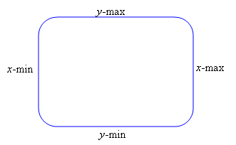

Graphing technologies draw graphs by plotting points (*x*, *f*(*x*)) between *x*-min and *x*-max. If there are any values of *x* between *x*-min and *x*-max for which *f*(*x*) is undefined, the graphing technology skips over those points and moves on to the next value of *x* in the domain. When finished with plotting, the graphing technology connects the points the same as we do when sketching a graph.

Graphing technologies are powerful tools; however, we must use them correctly, applying our mathematical knowledge to interpret what they render. In this lesson, we will provide some insight into how we can use graphing calculators and computers and interpret their output.

**Exercise 1.4.1: Graph a Function**

**Problem**

Graph the function *f*(*x*) = *x*–sin*x* in each of the following graphing windows:

1. <–2, 2, 1> by <–2, 2, 1>
2. <–4, 4, 1> by <0, 4, 1>
3. <0, 10, 1> by <0, 10, 1>
4. <–10, 100, 10> by <–10, 100, 10>

**Solution**

1. We write the following window dimensions for <–2, 2, 1> by <–2, 2, 1>: <–2, 2, 1> by <0, 1.4, 0.2>.

**Figure 1.4.2  
*f*(*x*) = *x*–sin*x* in <–2, 2, 1> by <0, 1.4, 0.2>**

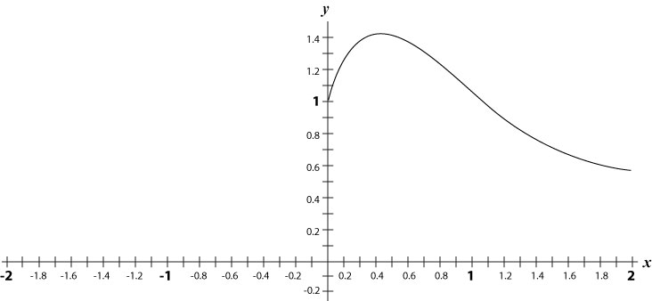

1. We write the following window dimensions for <–4, 4, 1> by <0, 4, 1>: <–4, 4, 1> by <0, 3, 1>.

**Figure 1.4.3  
*f*(*x*) = *x*–sin*x* in <–4, 4, 1> by <0, 3, 1>**

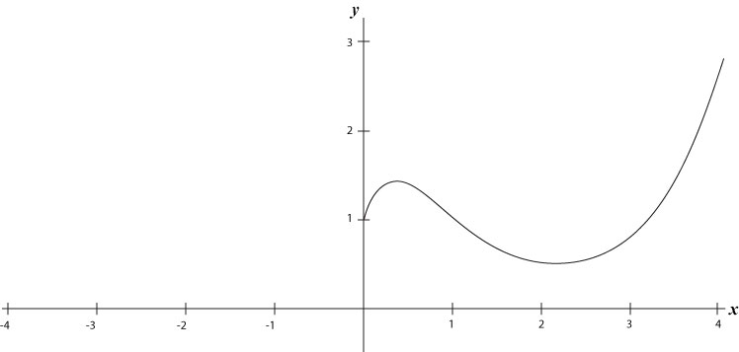

1. We write the following window dimensions for <0, 10, 1> by <0, 10, 1>: <–10, 10, 1> by <0, 10, 1>.

**Figure 1.4.4  
*f*(*x*) = *x*–sin*x* in <–10, 10, 1> by <0, 10, 1>**

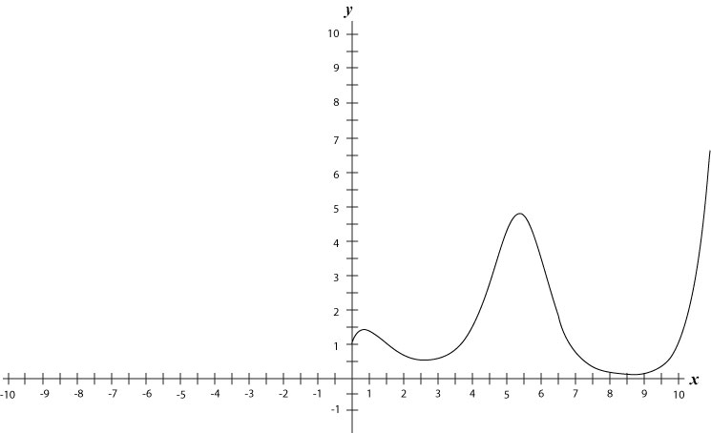

1. We write the following window dimensions for <–10, 100, 10> by <–10, 100, 10>: <–100, 100, 10> by <–10, 100, 10>.

**Figure 1.4.5  
*f*(*x*) = *x*–sin*x* in <–100, 100, 10> by <–10, 100, 10>**

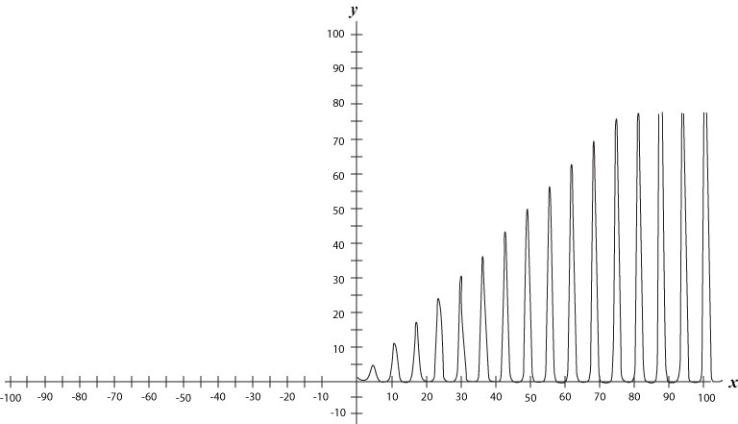

**Exercise 1.4.2: Set up a Graphing Window**

**Problem**

Determine an appropriate graphing window for the function *f*(*x*) = https://content.umuc.edu/file/7bdece95-b196-4233-9313-aa904663b08e/1/MATH140-0909.zip/Modules/M1-Module_1/Lesson_4/images/exercise1-4-2-eq1.gif.

**Solution**

The domain of the function *f*(*x*) = https://content.umuc.edu/file/7bdece95-b196-4233-9313-aa904663b08e/1/MATH140-0909.zip/Modules/M1-Module_1/Lesson_4/images/exercise1-4-2-eq1.gif is all *x*, such that 49*x*2 – *x*4 ≥ 0.

49*x*2 – *x*4 ≥ 0

*x*2(49 – *x*2) ≥ 0

*x*2 ≥ 0 for all real *x*; therefore, we focus on 49 – *x*2 ≥ 0.

49 – *x*2 ≥ 0

*x*2 ≤ 49

|*x*| ≤ 7 → –7 ≤ *x* ≤ 7

Thus, the domain of *f* is the interval [–7, 7]. We also note that 0 ≤ https://content.umuc.edu/file/7bdece95-b196-4233-9313-aa904663b08e/1/MATH140-0909.zip/Modules/M1-Module_1/Lesson_4/images/exercise1-4-2-eq1.gif< 25 (this can be easily verified numerically).

An appropriate graphing window is determined by setting the <*x*-min, *x*-max, *x*-scl> by <*y*-min, *y*-max, *y*-scl> so that the dimensions are slightly larger than the domain and range of the function.

Using the graphing window <–10, 10, 1> by <–5, 30, 5>, we obtain the graph shown in figure 1.4.6:

**https://content.umuc.edu/file/7bdece95-b196-4233-9313-aa904663b08e/1/MATH140-0909.zip/Modules/M1-Module_1/Lesson_4/images/MATH140-fig-1-4-6-fighead.gif**

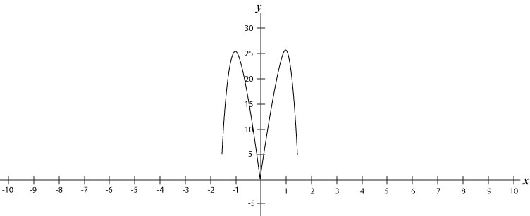

**Rectangular Graphing Window vs. Square Graphing Window**

The graphing window of many graphing calculators is approximately 1.5 times wider than its height. If we use the default standard zoom window, <–10, 10, 1> by <–10, 10, 1>, the graph will be distorted (as the distance between the *x* and *y* tick marks will not be the same.

With the default, the distance between the *x* tick marks is greater than the distance between the *y* tick marks, so that the graph appears stretched more widely than it would in a **square zoom window**, in which the *x*-scl and *y*-scl are scaled the same way. For example, the upper half of a circle might appear more like the upper half of an ellipse in the default standard zoom window. You would put your graphing calculator in the square zoom window mode to make the graph appear more like the upper half of a circle.

**Exercise 1.4.3: Compare Graphing Windows**

**Problem**

Graph the function https://content.umuc.edu/file/7bdece95-b196-4233-9313-aa904663b08e/1/MATH140-0909.zip/Modules/M1-Module_1/Lesson_4/images/sqrt-25-x-sq.gifusing a graphing calculator, and indicate the domain and range of *f*. What shape is this?

**Solution**

When we render the graph of *f* in the default display window (ZStandard on a TI graphing calculator), the graph of the semicircle of radius 5 appears more like the upper half of an ellipse.

**Figure 1.4.7a  
Semicircle in Display Window with ZStandard Setting**

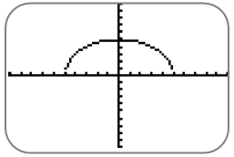

By setting the display window to ZSquare, we obtain a graph of *f* that appears more like the semicircle of radius 5.

**Figure 1.4.7b  
Semicircle in Display Window with ZSquare Setting**

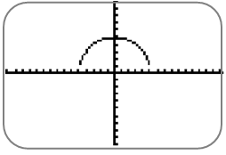

**Fixed Display Window**

Most graphing calculators adopt the approach of predetermining a default display window. Both the *x*-values and the *y*-values are set to a default, which is typically <–10, 10, 1> by <–10, 10, 1>. You may change the settings for *x*-min, *x*-max, *x*-scale, *y*-min, *y*-max, and *y*-scl to obtain a more suitable display window when necessary.

**Automatic Display Window**

Some computer graphing software programs adopt the approach of predetermining the *x*-values and then having the software program adjust the display window to an appropriate range of *y*-values for the desired graph. The automatic display window can give a misleading picture for some functions, such as *f*(*x*) = (*x* – 1)(*x* – 1000).

**Exercise 1.4.4: Graph a Function in the Default Graphing Window**

**Problem**

Graph the function *f*(*x*) = https://content.umuc.edu/file/7bdece95-b196-4233-9313-aa904663b08e/1/MATH140-0909.zip/Modules/M1-Module_1/Lesson_4/images/1-ovr-x-2.gif.

**Solution**

Figure 1.4.8 shows the graph of *f* in the default graphing window, <–10, 10, 1> by <–10, 10, 1>, of the TI-83 graphing calculator. The graphing calculator has attempted to connect the graph at *x* = 2 on the top and bottom of the screen, producing what appears to be a vertical line at *x* = 2. This line is not part of the actual graph, as the domain of *f*(*x*) = 1/(*x* – 2) is {*x* | *x* ≠ 2}. We can eliminate the line by adjusting the graphing window to <–4, 4, 1> by <–4, 4, 1>, and so obtain a better graph.

**https://content.umuc.edu/file/7bdece95-b196-4233-9313-aa904663b08e/1/MATH140-0909.zip/Modules/M1-Module_1/Lesson_4/images/MATH140-fig-1-4-8-fighead.gif**

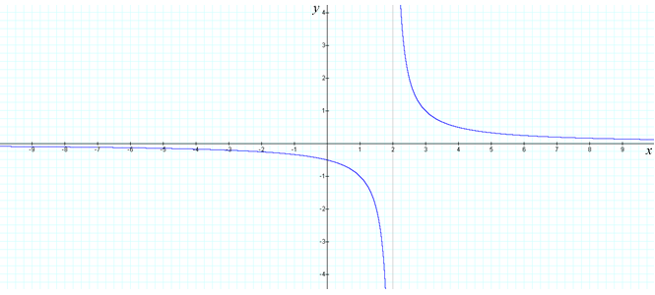

The figure does NOT show the vertical line *x* = 2 <–4, 4, 1> by <–4, 4, 1>.

**Exercise 1.4.5: Graph a Function and Describe Changes**

**Problem**

Graph the function *g*(*x*) = *x*4 + *ax*2 for different values of *a*. Describe how the graph changes as you change the value of *a*.

**Solution**

**Figure 1.4.9a  
*g*(*x*) = *x*4 + 2*x*2**

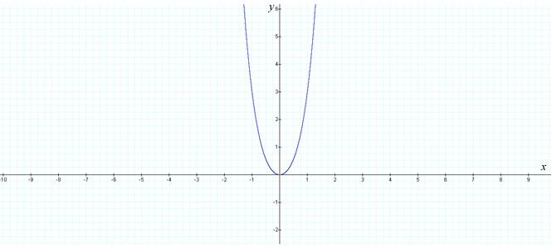

**Figure 1.4.9b  
*g*(*x*) = *x*4 + *x*2**

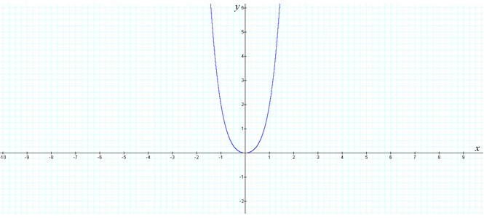

**Figure 1.4.9c  
*g*(*x*) = *x*4**

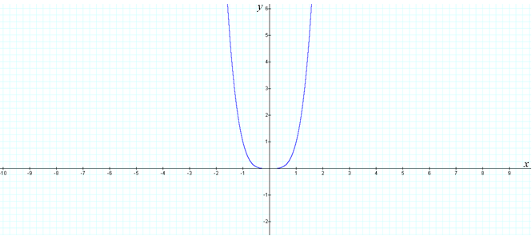

**Figure 1.4.9d  
*g*(*x*) = *x*4 – *x*2**

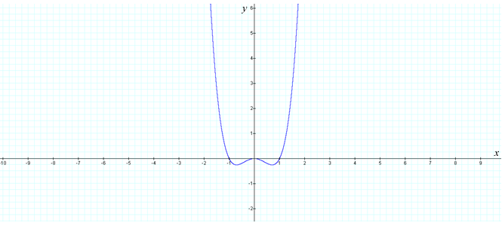

**Figure 1.4.9e  
*g*(*x*) = *x*4 – 2*x*2**

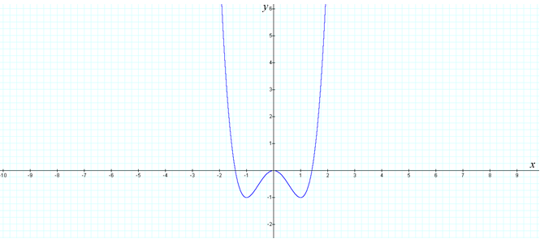

**Exercise 1.4.6: Approximate the Solution to an Equation**

**Problem**

Approximate the solution to equation 2*x* = *x*–*x* correct to two decimal places.

**Solution**

First, we note that the solution to the equation 2*x* = *x*–*x* is the *x*-coordinates of the points of intersection of the graphs of *y* = 2*x* and *y* = *x*–*x*. Using a graphing utility, we sketch the graphs of *y* = 2*x* and *y* = *x*–*x* on the same coordinate system (see figure 1.4.10a). Looking at the graphs, we can see that there is one point of intersection.

To determine an approximation of this point of intersection, we can zoom in closer (see figures 1.4.10b and 1.4.10c). We can approximate the point of intersection through observation, tracing the cursor along one of the curves until it appears to reach the point of intersection, or through the use of the Intersection feature found in most graphing utilities.

A reasonable approximation of the point of intersection of the two curves *y* = 2*x* and *y* = *x*–*x* is (0.66, 1.32). Therefore, a reasonable approximation of the solution, correct to two decimal places, is *x* = 0.66.

Below, observe our process of finding the solution:

**Figure 1.4.10a  
<–5, 5, 1> by <–5, 5, 1>**

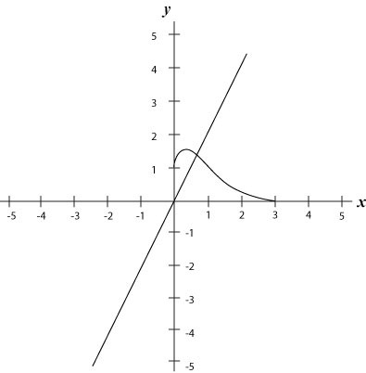

**Figure 1.4.10b  
<0, 2, 1> by <0, 2, 1>**

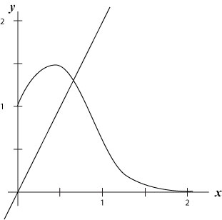

**Figure 1.4.10c  
<0, 1.5, 0.1> by <0, 2, 1>**

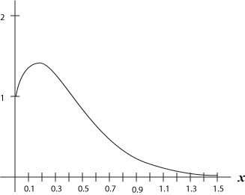

**Conclusion**

In this module, we provided you with a brief overview of the study of functions. We also explored some relevant applications of this study. In the next module, we will discuss what it means for a function to be continuous (or not continuous), and we will introduce the concept of the *limit*.

[*Return to top of page*](https://content.umuc.edu/file/7bdece95-b196-4233-9313-aa904663b08e/1/MATH140-0909.zip/Modules/M1-Module_1/Lesson_4/S3-Commentary.html#pagetop)

[**Report broken links or any other problems on this page.**](http://help.umuc.edu/)  
  
[**Copyright © by University of Maryland University College.**](https://content.umuc.edu/file/7bdece95-b196-4233-9313-aa904663b08e/1/MATH140-0909.zip/common/copyright.html)